Employee Name: Employee ID #: _____Date: ________________

Disclaimer: Competency Verification Records (CVR) are temporarily stored in the Department’s competency filing system until completion has been recorded on a permanent competency form (e.g., OCA, ACR). The CVR requires a validator’s signature.

Transfer of CVR to Permanent Record: With this record of a validated competency, the preceptor, Dept. NEC, manager, or their designee locates the matching competency statement on the Annual Competency Record (ACR), Orientation Competency Assessment (OCA) Regional Competency Assessment (RCA), or Department Specific Competency (DSC) form. (If the statement is not present, it can be written-in.) The competency statement is then initialed and dated as complete.

Competency Statement: | Demonstrates removal of subcutaneous anchor securement system (SASS).
Validator(s): | RN Vascular Access RN and clinicians who have validated and document competency for this skill.
Validator Documentation Instructions: | Validator documents method of validation (below) and initials each skill box once completed and places their full name, signature, and completion date at the end of the document.
Method of Validation: | DO Direct Observation – Return demonstration or evidence of daily work.  T Test: Written or oral assessments, surveys or worksheets, passing grade on a CBL test.  S Simulation  C Case Study/ Scenarios: Create/share a story of a situation then ask questions that capture the nature of the competency that is being referenced.  D Discussion: Identify questions related to a competency and ask orientee to provide an example of their real-life experiences.  R Reflection: A debriefing of an actual event or a discussion of a hypothetical situation.  QI Quality Improvement Monitoring: Audits or compliance checks on actual work or documentation to ensure the competency is completed.  N/A If the specific product or process step is not used in the respective area or by the respective role, then this step is deemed N/A.
Validation Instructions:

Demonstrated Skill  Behaviors for Competency (Critical Behaviors in Bold) | Method of Validation | Evaluator’s Initials
Verifies Licensed Independent Provider (LIP) order for catheter removal | D
Describes potential complications and risks | D
Explains device removal procedure to the patient | DO
Gathers Supplies:  - Sterile gloves  - Sterile gauze  - Antiseptic solution (Chlorohexidine, for allergy Betadine Applicator)  - Transparent Tegaderm dressing  - Vaseline gauze  - Mask(s)  - Goggles or eye protection  - Sterile blunt-tipped scissors | DO
Removes the dressing per hospital protocol | DO
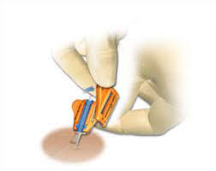  Demonstrates removal of SASS cover:  - Place a finger of the non-dominant hand under the device to prevent twisting  - Secure the catheter with your non-dominant fingers  - Grasp the tab on the cover with the dominant hand and lift it away to detach completely from anchor base | DO
Removes the catheter | DO
Applies pressure to insertion site, per hospital protocol, until hemostasis has been obtained | DO
Identifies which method of removal is most appropriate: fold or split option for base removal | D
Fold Option  - Apply firm pressure at the insertion site.  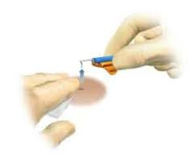  - Fold base wings downward, keeping the channel parallel to the skin  - Use a swift upward motion to remove, following the shape of the feet  - Apply a sterile dressing over the site and discard the device in a biohazard container | DO
Split Option  - Use blunt-tip scissors to cut the anchor base along the catheter groove  - Make the skin taut and remove each half of the anchor base swiftly.  - Apply a sterile dressing and discard the device in a biohazard container  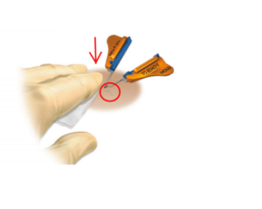  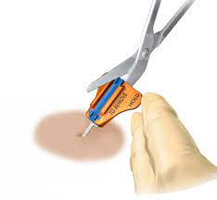 | DO
Visually inspects the SASS to ensure full removal | DO
Discards device in a biohazard container/bag (it is not considered a sharp) | DO
Performs documentation including completion of line LDA | DO
Identifies clinician resources for escalating insertion concerns:  - IR Physician Assistant/IR on-call Attending  - VAT nurses  - Specific device representatives | D

Competency Verified by:

Date: _______________
Validator’s Name (printed) Validator’s signature

References:

- Securacath. (n.d.). Placement & removal procedures. Securacath. https://securacath.com/clinician-resources/placement-removal-procedures/
- Securacath. (2024, July). SecurAcath competency checklist. Securacath. https://securacath.com/wp-content/uploads/2024/07/1329-049-rA-SecurAcath-Competency-Checklist.pdf

